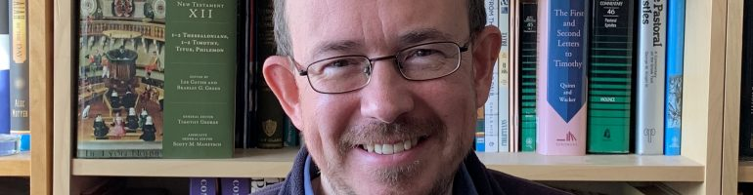
I’m a Christian, in the Reformed and Evangelical tradition of the Church of England, and an author of books and articles on the Bible, theology, Anglicanism, and church history.
I’m from a northern working-class background, although my family moved around the country as I was growing up and I went to various state schools in County Durham, Gloucester, Kent, and Manchester. As the first in my family to go to university, I studied Modern History at New College, Oxford. After working for St. Ebbe’s Church in Oxford for a while, I was a student on the Cornhill Training Course in London, with a placement doing student work at All Soul’s, Langham Place, where my wife Kerry was working as a Lay Assistant. From there we went on to do Theological & Pastoral Studies at Oak Hill Theological College in London, and I stayed on for a fourth year to continue (but sadly not finish) M.Phil. masters research into the Old Testament (intertextuality in Malachi).
After ordination, I served for three years as the Curate of St. Botolph’s, Barton Seagrave and St. Edmund’s, Warkton in the Diocese of Peterborough. Then for more than five years I was the Associate Minister of St. Helen’s, Bishopsgate in the City of London with responsibility for the Sunday Morning congregation and midweek groups as well as leading the Church Family staff team, and co-ordinating Reform London. While in London I also completed a ThM in Historical and Systematic Theology with Westminster Theological Seminary (Philadelphia, USA). I then spent 2009-2012 researching Post-Reformation biblical interpretation at Peterhouse and Tyndale House, Cambridge (where I was awarded the Lightfoot Scholarship and Archbishop Cranmer Prize). I got a PhD out of that, and since January 2013, I’ve been the full time Director of Church Society.

I’m married to Kerry and we have three children. In addition to founding an internet journal called Theologian, I am privileged to serve as a member of the Editorial Board of the journals The Global Anglican (formerly known as Churchman) and Studies in Puritanism & Piety, having previously served for Themelios, and as Editor of Foundations (2019). I’ve published a number of scholarly articles in these journals and others such as Reformed Theological Review, Tyndale Bulletin, Southern Baptist Journal of Theology, Crux, Faith and Worship, Unio Cum Christo, La Revue Reformee, and Evangelical Quarterly, as well as nine articles in the Encyclopaedia of Christian Education. I’ve also published well over 100 reviews in some of these journals and others such as Theology, The Journal of Theological Studies, Reading Religion, and the Journal of Ecclesiastical History, mainly focusing on biblical commentaries and church history.
I’ve written and edited over 30 books with publishers such as the Latimer Trust, Church Society / Lost Coin, Hodder & Stoughton, Evangelical Press, Christian Focus, Good Book Company, IVP Academic, and Crossway, which are available via Amazon and other places. I’ve also contributed to academic symposium volumes with Ashgate and T&T Clark, as well as more popular-level publications such as The Church of England Newspaper, Evangelicals Now, Evangelical Times, Modern Reformation, The Briefing, The Gospel Magazine, Crossway, and TableTalk.
I am on the Church of England Evangelical Council and the Council of Affinity. I’m a Trustee of the annual St Antholin Lecture. In the past, I’ve taught 15-17th century church history to undergraduates and ordinands at Cambridge University, been a Research Fellow at the Jonathan Edwards Centre Africa at the University of the Free State, South Africa, an Adjunct Professor at Puritan Reformed Theological Seminary, Grand Rapids, a Visiting Lecturer at the University of Roehampton, and a member of the Latimer Trust Theological Workgroup. I have been a Lecturer in Church History at Union School of Theology in Wales since 2011.
In the last few years I have preached and lectured at several theological colleges, training courses, conferences, and conventions in the UK, as well as conferences and events in Germany, Ireland, South Africa, Chile, Canada, and various places in the USA. I was a main speaker on the Theologians Network at the European Leadership Forum in Hungary (2011), and speak (almost) annually for churches in Athens, Greece as well as at The Greek Bible College there. I was privileged to be part of the British delegation to the Global Anglican Future Conference (GAFCON) in Nairobi, Kenya (2013) and Jerusalem (2018). In August 2020, I was invited to lead and preach for the Church of England’s National Online Service:

To relax, I play football, table tennis, or Risk with the family, and I greatly enjoy reading ancient Greek and Latin classics (Homer, Ovid, Juvenal etc), listening to New Order, Handel, and Canteloube, watching sci-fi and spy-fi and The Middle, and supporting Manchester United (having lived 10 minutes from Old Trafford as a teenager). Frustratingly, my extended family supports Manchester City! I used to write songs such as Better Time and One Way Street, but my main claim to fame is that my brother Dean was once an actor (appearing for example in this Nat West advert).
Since I’m often asked… if you want to say it right (which would be kind), Gatiss is pronounced Gate-iss and definitely not Gatt-is (since it’s the Middle English plural of Gate). If you can pronounce it with a North-eastern English accent you get extra brownie points (I’m originally from County Durham), and the spelling is one tea, with two sugars. I may have had a Reformation martyr as an ancestor, which I talk about in this sermon. You might also find me blogging occasionally with others at Church Society, or over at Meet the Puritans, or Reformation21.
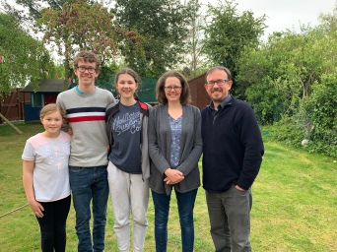
https://leegatiss.wordpress.com/about/

